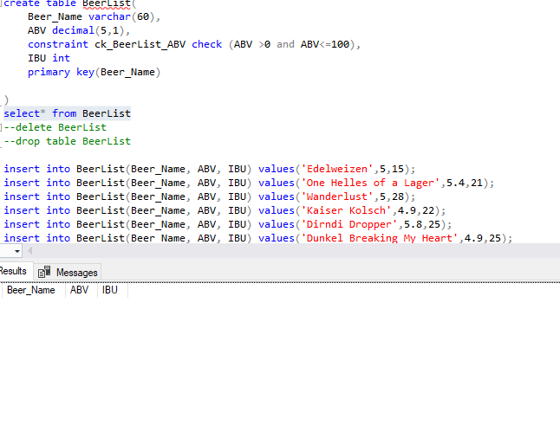

insert into BeerList(Beer_Name, ABV, IBU) values('Edelweizen',5,15);

insert into BeerList(Beer_Name, ABV, IBU) values('One Helles of a Lager',5.4,21);

insert into BeerList(Beer_Name, ABV, IBU) values('Wanderlust',5,28);

insert into BeerList(Beer_Name, ABV, IBU) values('Kaiser Kolsch',4.9,22);

insert into BeerList(Beer_Name, ABV, IBU) values('Dirndi Dropper',5.8,25);

insert into BeerList(Beer_Name, ABV, IBU) values('Dunkel Breaking My Heart',4.9,25);

insert into BeerList(Beer_Name, ABV, IBU) values('Doppelsticke',8,60);

insert into BeerList(Beer_Name, ABV, IBU) values('Vom Fass No.2',8.9,60);

insert into BeerList(Beer_Name, ABV, IBU) values('Weizenbock',8.5,18);

insert into BeerList(Beer_Name, ABV, IBU) values('Old World Weizen',5.4,13);

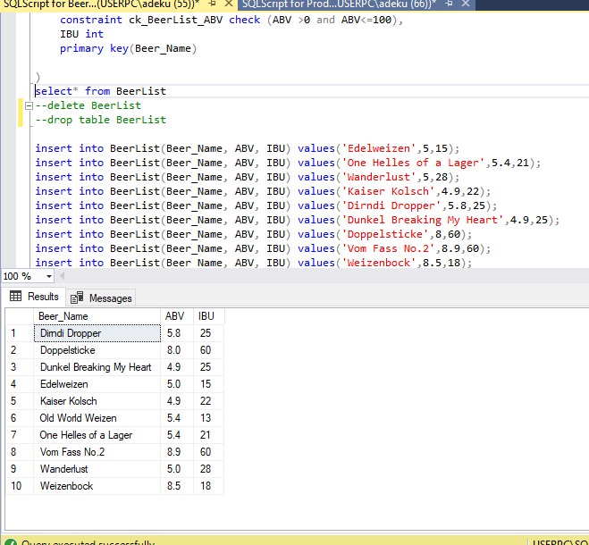

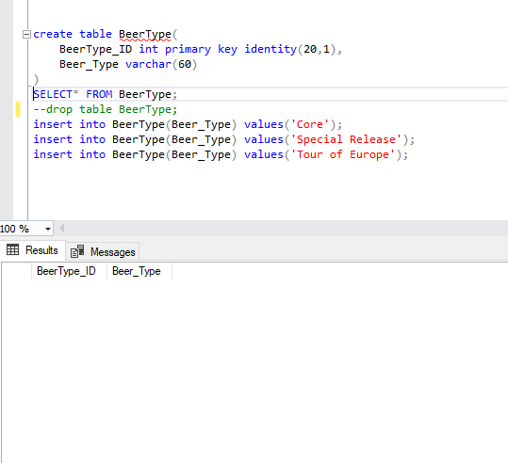

insert into BeerType(Beer_Type) values('Core');

insert into BeerType(Beer_Type) values('Special Release');

insert into BeerType(Beer_Type) values('Tour of Europe');

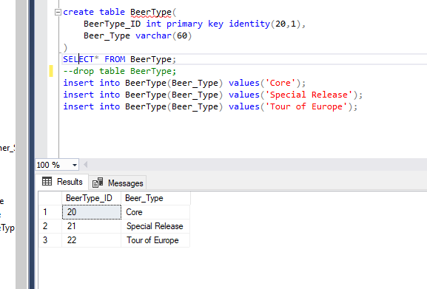

insert into Beer_Container_Size(Container_Name,Size) VALUES('Growler Fill', '32-ounce');

insert into Beer_Container_Size(Container_Name,Size) VALUES('Growler Fill', '64-ounce');

insert into Beer_Container_Size(Container_Name,Size) VALUES('Growler Fill', 'Gallon');

insert into Beer_Container_Size(Container_Name,Size) VALUES('Keg', 'Quarter Barrel');

insert into Beer_Container_Size(Container_Name,Size) VALUES('Keg', '50 Liter');

insert into Beer_Container_Size(Container_Name,Size) VALUES('Bottle', '22-ounce');

insert into Beer_Container_Size(Container_Name,Size) VALUES('Glass', '6-ounce');